ARTIFICIAL INTELLIGENCE – BASICS
Learning from Data
Making Machines Smarter
Study notes for UG Second Year students

What you will learn in these notes
• What it means for a machine to “learn” and why data is the fuel for learning
• How machine learning differs from ordinary programming
• The machine learning workflow, step by step
• Supervised, unsupervised and reinforcement learning with examples
• Basic algorithms: linear regression, k-NN, decision trees, k-means, neural networks
• Training, testing, overfitting and how to measure a model’s performance
• Real-world applications, challenges and ethics

1. Introduction: Can Machines Learn?
Humans learn from experience. A child who touches a hot cup learns to be careful next time. Nobody writes down a rule for every cup in the world; the child generalises from a few experiences. Machine Learning (ML), a core branch of Artificial Intelligence (AI), tries to give computers the same ability: to improve at a task by studying data, instead of being told every step explicitly.
Think about how an email service recognises spam. It is almost impossible to write rules for every spam message that exists. Instead, we show the computer thousands of emails already marked “spam” or “not spam”. The computer finds patterns on its own and then uses them to judge new emails. This is learning from data.
Definition (Tom Mitchell, 1997)
“A computer program is said to learn from experience E with respect to some task T and performance measure P, if its performance at T, as measured by P, improves with experience E.”
Example: T = classifying emails as spam; E = a collection of labelled emails; P = percentage of emails classified correctly.

1.1 Where does ML fit in AI?
Artificial Intelligence is the broad goal of making machines behave intelligently. Machine Learning is one way of achieving this goal, and Deep Learning is a special kind of machine learning that uses large neural networks.
- Artificial Intelligence (AI): any technique that lets machines mimic human intelligence (reasoning, planning, understanding language).
- Machine Learning (ML): a subset of AI where systems learn patterns from data.
- Deep Learning (DL): a subset of ML that uses multi-layer neural networks, very good with images, speech and text.

2. Data: The Fuel of Learning
Data is a collection of facts, measurements or observations. In machine learning, we usually arrange data in a table. Each row is one example (also called a sample, record or instance) and each column describes one property of that example.
Study hours | Attendance % | Previous marks | Internet at home | Result (label)
6 | 92 | 78 | Yes | Pass
2 | 55 | 40 | No | Fail
5 | 85 | 66 | Yes | Pass
1 | 48 | 35 | Yes | Fail
Table 1: A tiny dataset to predict whether a student passes

2.1 Important terms
Term | Meaning
Dataset | The full collection of examples used for learning.
Feature (input, attribute) | A measurable property used to make the decision, e.g. study hours, attendance.
Label (target, output) | The answer we want the model to predict, e.g. Pass or Fail.
Model | The pattern or mathematical function the algorithm learns from the data.
Training | The process of letting the algorithm learn the model from data.
Prediction (inference) | Using the trained model on new, unseen data.

2.2 Types of data
- Numerical data: numbers that can be measured or counted (height, marks, temperature).
- Categorical data: groups or categories (blood group, city, Pass/Fail).
- Text, image, audio and video data: unstructured data that must be converted into numbers before a model can use it.
- Time-series data: values recorded over time (daily stock price, hourly temperature).

2.3 Why data quality matters
A model can only be as good as the data it learns from. The popular saying “Garbage In, Garbage Out” captures this. Good data should be:
- Sufficient: enough examples to show the real patterns.
- Accurate: free from wrong values and errors.
- Representative: covering all the situations the model will meet in real life.
- Unbiased: not favouring or ignoring any group unfairly.
- Clean: missing values, duplicates and outliers handled properly.

3. Traditional Programming vs Machine Learning
In traditional programming, a human studies the problem, writes the rules and feeds data to the program to get answers. In machine learning, we do the opposite: we give the computer the data and the answers, and it works out the rules (the model) by itself. Those learned rules can then be applied to new data.
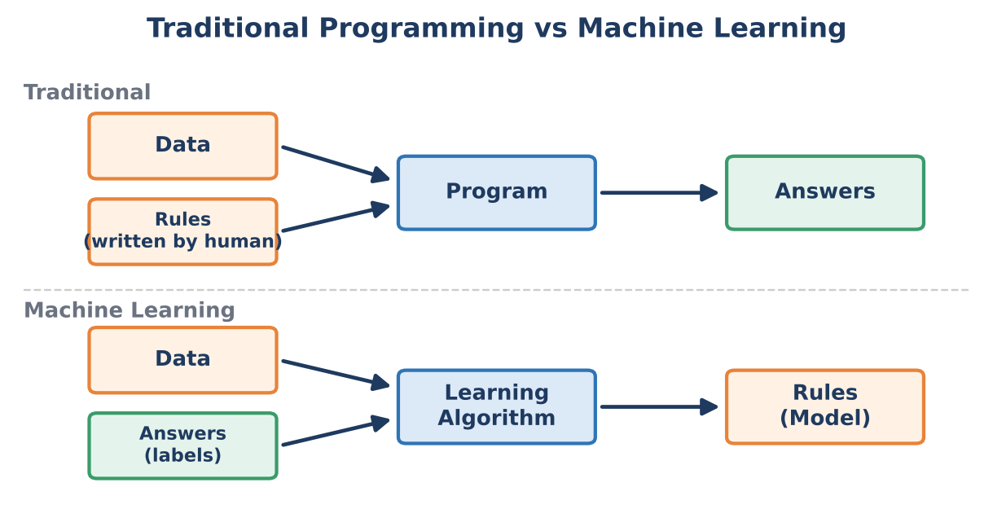
Figure 1: Traditional programming vs machine learning
Aspect | Traditional Programming | Machine Learning
Rules | Written by the programmer | Learned from data
Input | Data + rules | Data + answers (for supervised learning)
Output | Answers | Rules / model
Best for | Clear, fixed logic (payroll, calculator) | Complex patterns (face recognition, speech, spam)
Adapts to change? | Programmer must rewrite code | Can be retrained with new data

4. The Machine Learning Workflow
Building a learning system follows a series of steps. In practice we often go around the loop several times until the results are good enough.
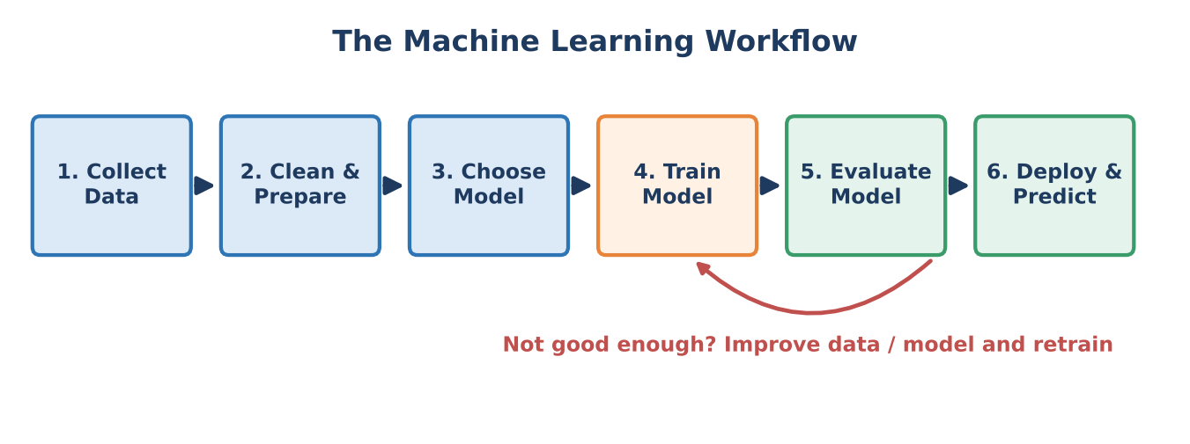
Figure 2: Steps in building a machine learning system
- Collect data: gather examples from sensors, databases, surveys, websites or logs.
- Clean and prepare data: remove duplicates, fill missing values, convert text/categories into numbers and scale values to similar ranges. This step often takes the most time.
- Choose a model: pick a suitable algorithm (for example linear regression, decision tree or neural network) based on the problem.
- Train the model: show the training data to the algorithm so that it adjusts its internal parameters to reduce its mistakes.
- Evaluate the model: test it on data it has never seen and measure accuracy or error. If it is poor, improve the data or the model and train again.
- Deploy and predict: use the model in a real application (a mobile app, a website, a machine) and keep monitoring it.

5. Types of Machine Learning
Machine learning is usually divided into three families depending on the kind of feedback available to the learner.
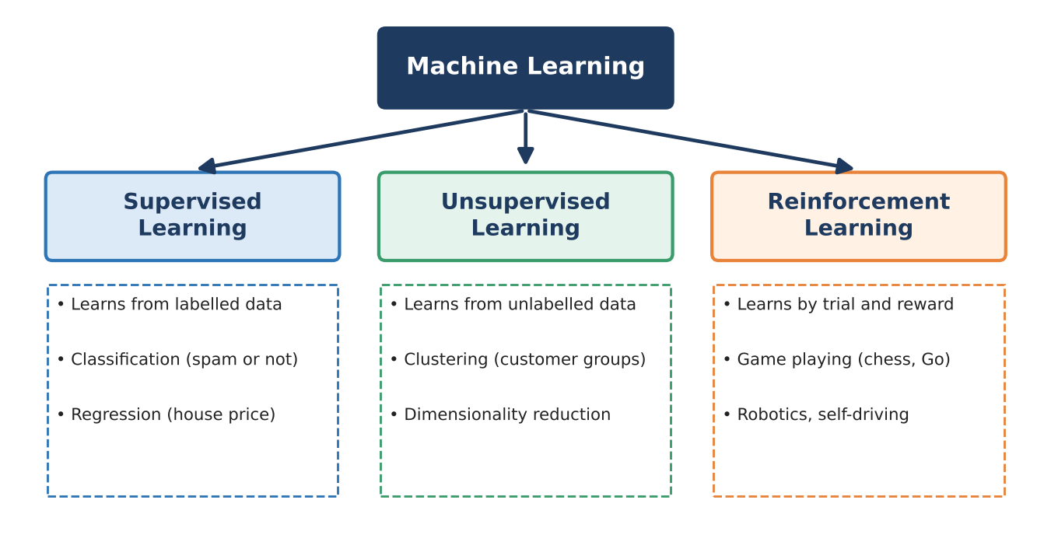
Figure 3: The three main types of machine learning

5.1 Supervised learning
In supervised learning the data is labelled: each example comes with the correct answer, like a student learning with a teacher who checks every answer. The algorithm learns the mapping from inputs (features) to outputs (labels). There are two main kinds of supervised problems.

(a) Classification – predicting a category
The output is a class or category. Examples: spam / not spam, disease / no disease, handwritten digit 0–9. The model learns a decision boundary that separates the classes.
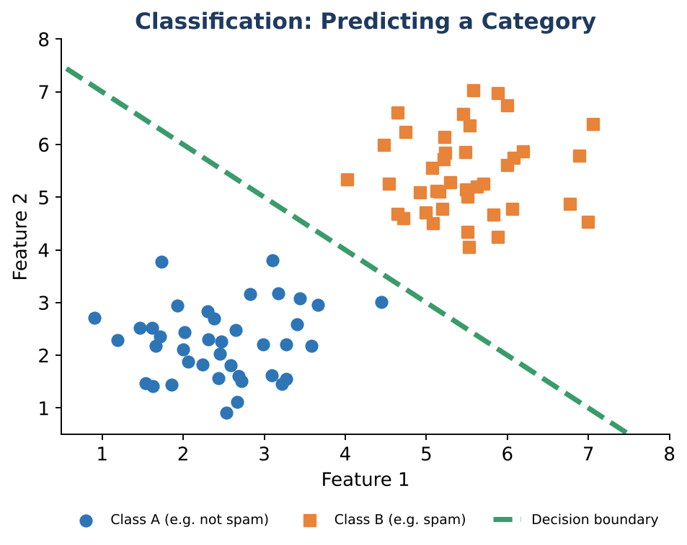
Figure 4: Classification – a boundary separates two classes

(b) Regression – predicting a number
The output is a continuous number. Examples: price of a house, tomorrow’s temperature, a student’s marks. The simplest model fits a straight line through the data, y = m·x + c, where m is the slope and c the intercept.
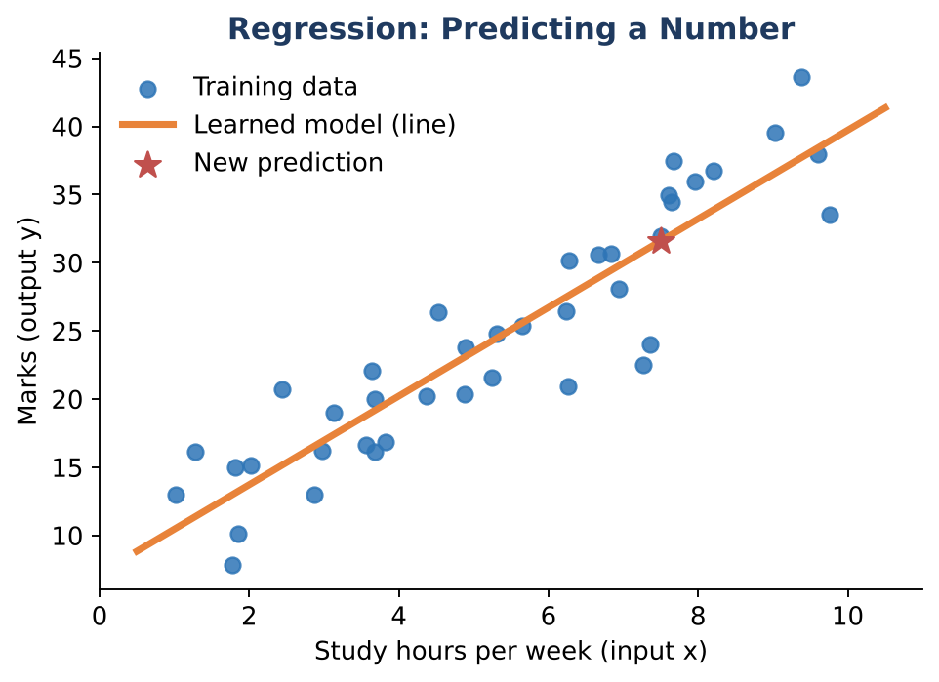
Figure 5: Regression – a line learned from data predicts a new value

5.2 Unsupervised learning
Here the data has no labels. The algorithm explores the data on its own to discover hidden structure, like sorting a heap of mixed coins into groups without being told the categories.
- Clustering: grouping similar items together (e.g. grouping customers by buying habits). A popular algorithm is k-means.
- Dimensionality reduction: compressing many features into a few important ones while keeping the main information (e.g. PCA).
- Association: finding items that occur together (e.g. people who buy bread often buy butter).
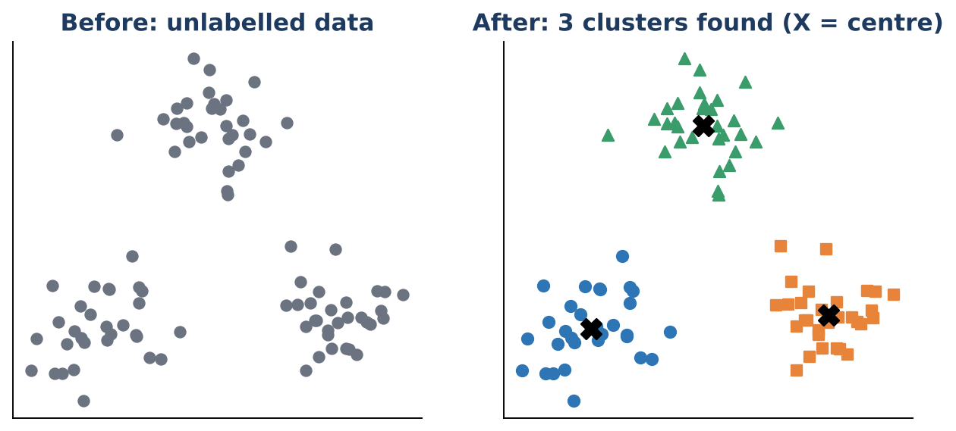
Figure 6: Clustering – finding groups in unlabelled data

5.3 Reinforcement learning
In reinforcement learning (RL) an agent learns by trial and error while interacting with an environment. After each action it receives a reward (good) or penalty (bad) and tries to maximise the total reward over time. It is like training a dog with treats.
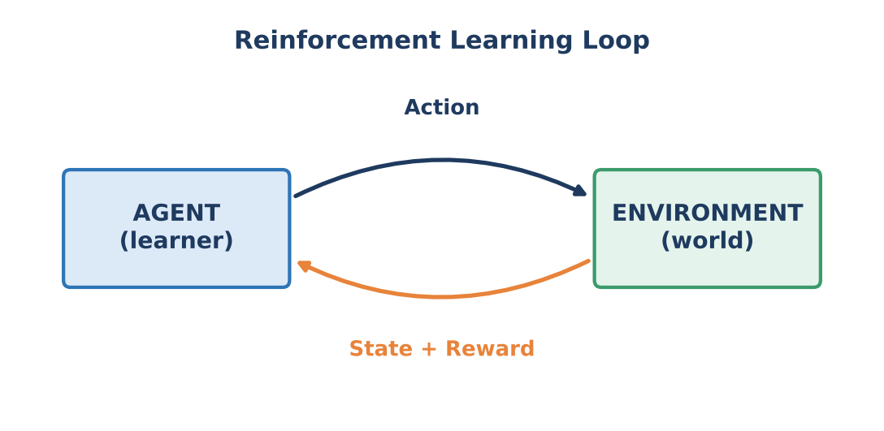
Figure 7: The reinforcement learning loop
Applications: game-playing programs (chess, Go), robot walking, self-driving car control, and recommendation systems that learn from user clicks.

5.4 Comparison at a glance
Feature | Supervised | Unsupervised | Reinforcement
Data | Labelled | Unlabelled | No fixed dataset; learns from interaction
Feedback | Correct answers given | None | Rewards and penalties
Goal | Predict labels / values | Find hidden patterns | Maximise long-term reward
Examples | Spam filter, price prediction | Customer segments | Game AI, robotics

6. Some Basic Learning Algorithms

6.1 Linear regression
Linear regression finds the best straight line through the data points. “Best” means the line that makes the total of the squared gaps between the line and the actual points as small as possible (the least squares method). With several features the equation becomes y = w₁x₁ + w₂x₂ + … + b, where w₁, w₂ … are weights that the algorithm learns.

6.2 k-Nearest Neighbours (k-NN)
k-NN classifies a new item by looking at the k closest examples in the training data and taking a majority vote. It is based on the idea that “similar things are near each other”. For k = 3, if two of the three nearest neighbours are class A and one is class B, the new point is labelled A. k-NN is simple and needs no training phase, but it can be slow for very large datasets.

6.3 Decision trees
A decision tree asks a sequence of yes/no questions about the features and follows the branches until it reaches a decision at a leaf. It is easy to understand and explain because it mirrors human decision-making.
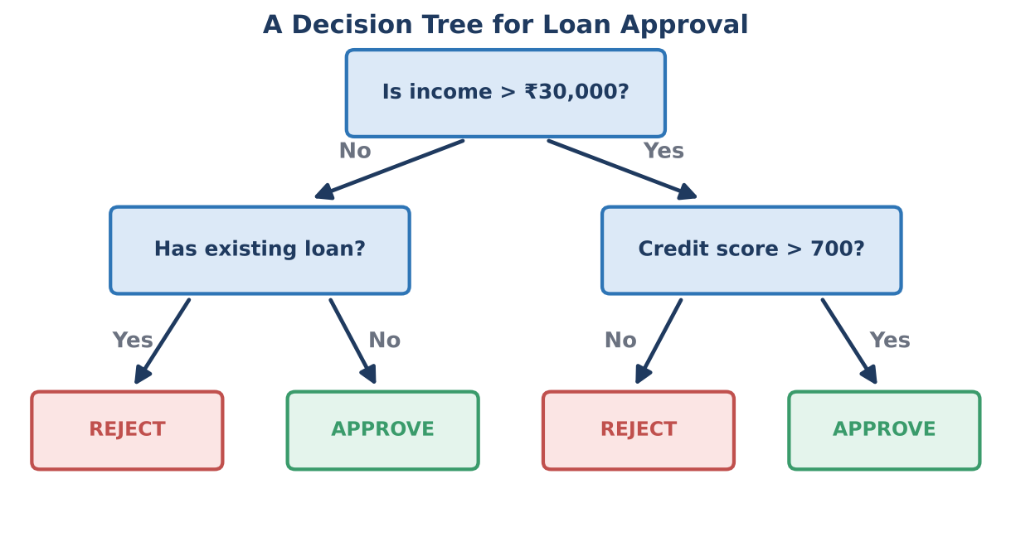
Figure 8: A decision tree deciding loan approval
- Root node: the first question asked.
- Branch: the outcome (Yes/No) of a question.
- Leaf node: the final decision or class.

6.4 k-Means clustering
k-means is an unsupervised algorithm that splits data into k groups. It works in a loop: (1) pick k starting centres; (2) assign each point to its nearest centre; (3) move each centre to the average position of its group; (4) repeat steps 2–3 until the groups stop changing.

6.5 Artificial neural networks
Neural networks are inspired by the human brain. They are built from many simple units called neurons. Each neuron multiplies its inputs by weights, adds them up with a bias, and passes the result through an activation function that decides how strongly the neuron “fires”.
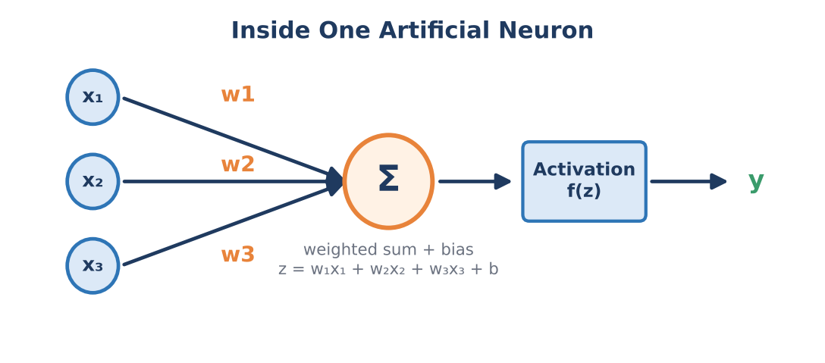
Figure 9: A single artificial neuron
Neurons are arranged in layers: an input layer that receives the data, one or more hidden layers that find patterns, and an output layer that gives the prediction. A network with many hidden layers is called a deep neural network, which is the basis of Deep Learning.
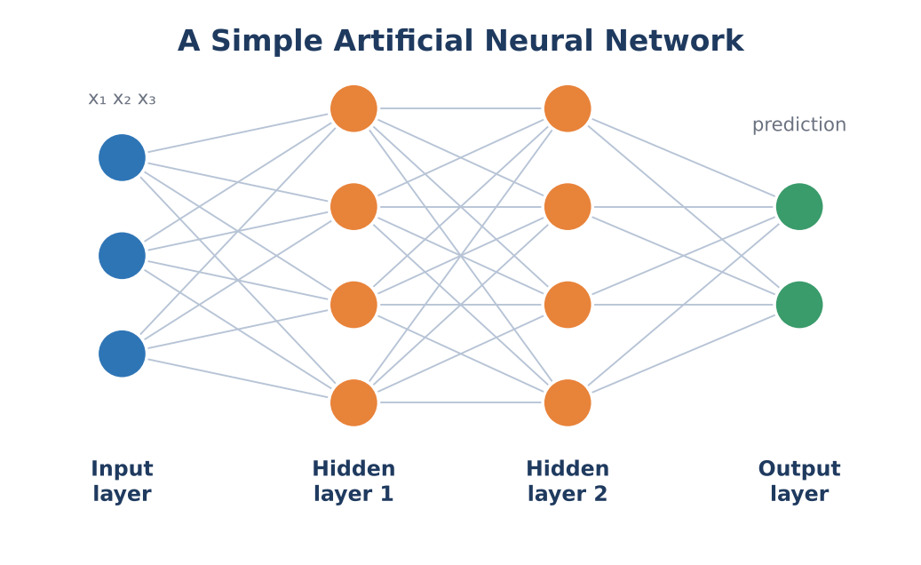
Figure 10: A neural network with two hidden layers
How does a neural network learn?
1. Start with random weights. 2. Feed an example and compute the output (forward pass). 3. Compare the output with the correct answer to get the error (loss). 4. Adjust the weights slightly to reduce the error (backpropagation with gradient descent). 5. Repeat over many examples and many rounds (epochs).

7. Training, Validation and Testing
A student who only memorises last year’s question paper may fail when new questions come. In the same way, we must check a model on data it has not seen during learning. So we split the dataset into parts:
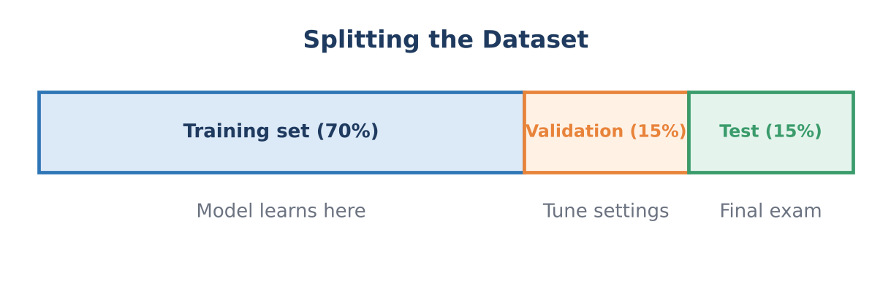
Figure 11: Splitting a dataset into training, validation and test sets
- Training set (about 60–80%): used by the algorithm to learn.
- Validation set (about 10–20%): used to compare models and tune settings (called hyperparameters, e.g. k in k-NN).
- Test set (about 10–20%): used only once at the end to estimate how the model will perform in the real world.
Golden rule
Never evaluate a model on the same data it was trained on. The test data must stay hidden until the very end.

8. Underfitting and Overfitting
The aim of learning is generalisation: doing well on new data, not just on training data. Two things can go wrong.
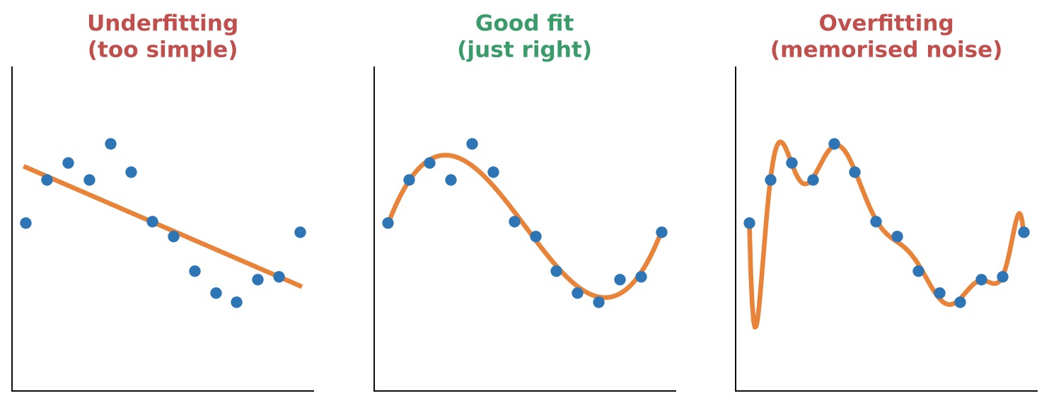
Figure 12: Underfitting, good fit and overfitting
Problem | What happens | How to reduce it
Underfitting | Model is too simple to capture the pattern. Poor on both training and test data (high bias). | Use a more powerful model, add useful features, train longer.
Overfitting | Model memorises training data including noise. Excellent on training data but poor on new data (high variance). | Collect more data, simplify the model, use regularisation, stop training early, use cross-validation.
Good fit | Model captures the real trend and performs well on new data. | This is the goal.

9. Measuring Performance
After training we need numbers that tell us how good the model is. The right measure depends on the task.

9.1 For regression
- Mean Absolute Error (MAE): the average size of the prediction errors.
- Mean Squared Error (MSE): the average of the squared errors; it punishes large errors more.

9.2 For classification: the confusion matrix
A confusion matrix counts how many predictions were right and wrong for each class. Take “spam” as the positive class.
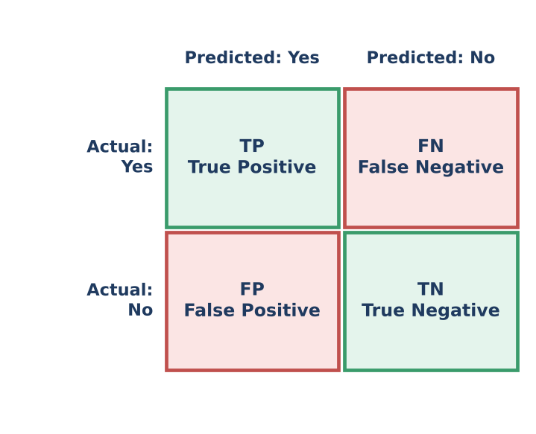
Figure 13: Confusion matrix
- TP (True Positive): spam correctly caught.
- TN (True Negative): normal mail correctly allowed.
- FP (False Positive): normal mail wrongly marked as spam.
- FN (False Negative): spam that slipped through.
Measure | Formula | Meaning
Accuracy | (TP + TN) / (TP + TN + FP + FN) | Fraction of all predictions that were correct.
Precision | TP / (TP + FP) | Of the items predicted positive, how many really were?
Recall | TP / (TP + FN) | Of all real positives, how many did we find?
F1-score | 2 × (Precision × Recall) / (Precision + Recall) | Balance between precision and recall.

Worked example
A spam filter tests 100 emails: TP = 40, TN = 45, FP = 5, FN = 10.
Accuracy = (40 + 45) / 100 = 0.85 (85%)
Precision = 40 / (40 + 5) = 40/45 ≈ 0.89
Recall = 40 / (40 + 10) = 40/50 = 0.80
F1 = 2 × (0.89 × 0.80) / (0.89 + 0.80) ≈ 0.84

Why not just use accuracy? If only 1% of patients have a disease, a model that always says “healthy” is 99% accurate but useless. Recall and precision reveal such failures.

10. Applications of Learning from Data
Area | Examples
Healthcare | Detecting diseases from X-rays and scans, predicting patient risk, drug discovery.
Agriculture | Crop disease detection from leaf photos, yield and rainfall prediction.
Finance | Fraud detection, credit scoring, stock trend analysis.
E-commerce & media | Product and movie recommendations, search ranking, price prediction.
Language | Translation, voice assistants, chatbots, spam filtering.
Transport | Self-driving vehicles, traffic prediction, route planning.
Education | Personalised learning, automatic grading, student dropout prediction.
Security | Face recognition, intrusion and malware detection.

11. Challenges and Ethical Concerns
- Need for large, good data: collecting and labelling data is costly.
- Bias and fairness: if data reflects unfair human decisions, the model will copy and even amplify them (for example, a hiring model that favours one group).
- Privacy: models are often trained on personal data, which must be protected.
- Explainability: complex models such as deep networks behave like a “black box”, making it hard to explain why a decision was made.
- Overfitting and changing environments: a model may stop working well when the real world changes (called data drift).
- Safety and accountability: who is responsible when an AI system makes a harmful mistake?
Responsible AI therefore requires diverse data, transparent methods, human oversight and respect for privacy and law.

12. Summary – Key Points to Remember
Quick revision
• Machine learning lets computers learn patterns from data instead of following hand-written rules.
• Data is made of features (inputs) and, in supervised learning, labels (answers). Data quality decides model quality.
• The workflow: collect → clean → choose model → train → evaluate → deploy.
• Supervised = labelled data (classification, regression); Unsupervised = unlabelled data (clustering); Reinforcement = learning by reward.
• Common algorithms: linear regression, k-NN, decision tree, k-means, neural network.
• Split data into train / validation / test to check generalisation.
• Underfitting = too simple; overfitting = memorising. Aim for a good fit.
• Evaluate with accuracy, precision, recall and F1 (classification) or MAE/MSE (regression).
• Use ML responsibly: watch for bias, privacy and transparency issues.

13. Practice Questions

A. Short answer (2 marks)
- Define machine learning using Mitchell’s definition.
- What is the difference between a feature and a label?
- Distinguish between classification and regression with one example each.
- What is overfitting? Give one way to reduce it.
- Why do we keep a separate test set?
- Name the three types of machine learning.

B. Descriptive (5 / 10 marks)
- Explain how traditional programming differs from machine learning with a neat diagram.
- Describe the steps in the machine learning workflow.
- Compare supervised, unsupervised and reinforcement learning with examples.
- Explain the structure of an artificial neuron and a neural network.
- What is a confusion matrix? Define accuracy, precision and recall.
- Explain underfitting and overfitting with the help of diagrams.

C. Numerical
- A model gives TP = 30, TN = 50, FP = 10, FN = 10. Calculate accuracy, precision, recall and F1-score.
- A dataset has 1000 records. Show how you would split it 70:15:15 into training, validation and test sets.

D. Think and discuss
- Suggest one problem in your college or city that could be solved by learning from data. Which type of learning would you use and what data would you collect?

14. Glossary
Term | Meaning
Algorithm | A step-by-step procedure the computer follows to learn from data.
Bias (in data) | Unfair skew in data that leads to unfair predictions.
Cluster | A group of similar data points.
Epoch | One complete pass through the training data.
Generalisation | The ability of a model to perform well on new, unseen data.
Hyperparameter | A setting chosen by the designer before training (e.g. k in k-NN).
Loss / error | A number that tells how wrong the model’s predictions are.
Noise | Random errors or irrelevant variation in data.
Parameter / weight | A value inside the model that is adjusted during training.
Reward | Feedback signal in reinforcement learning.

— End of Notes —

